**LAB -12**

**Final Demonstration of the Project as per the proposal.**

**By: - Gaurav Gupta(18MIS7107)**

**Amit Kumar Sahu(18MIS7250)**

**All the screenshots are taken form the local server that is hosted by XAMPP**

1. **Login: -**

Allow User to Login to the account and explore our website.

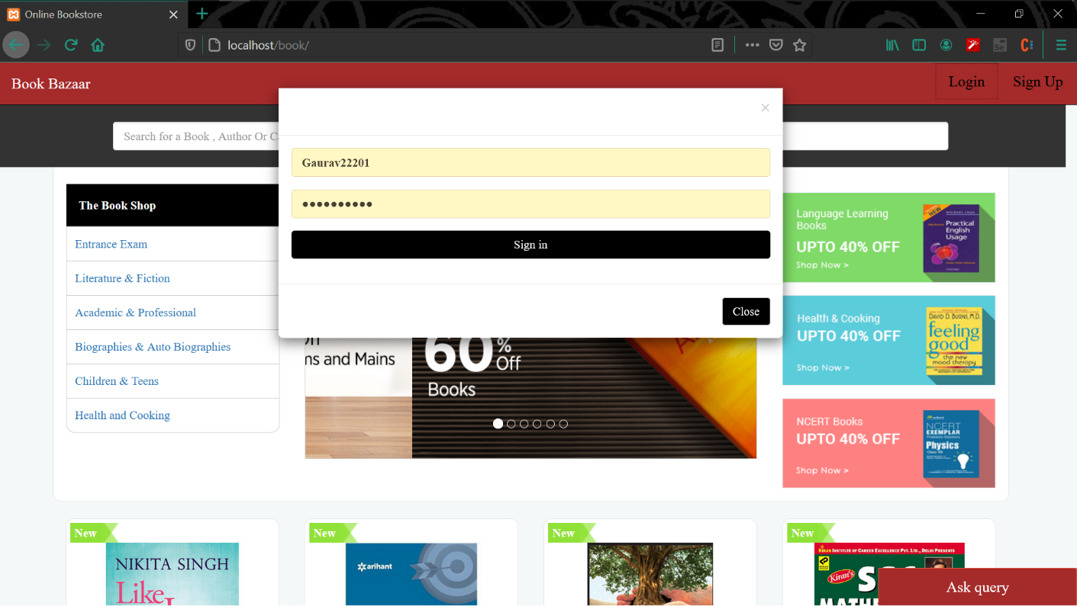

1. **Register: -**

Register a new account as a new user.

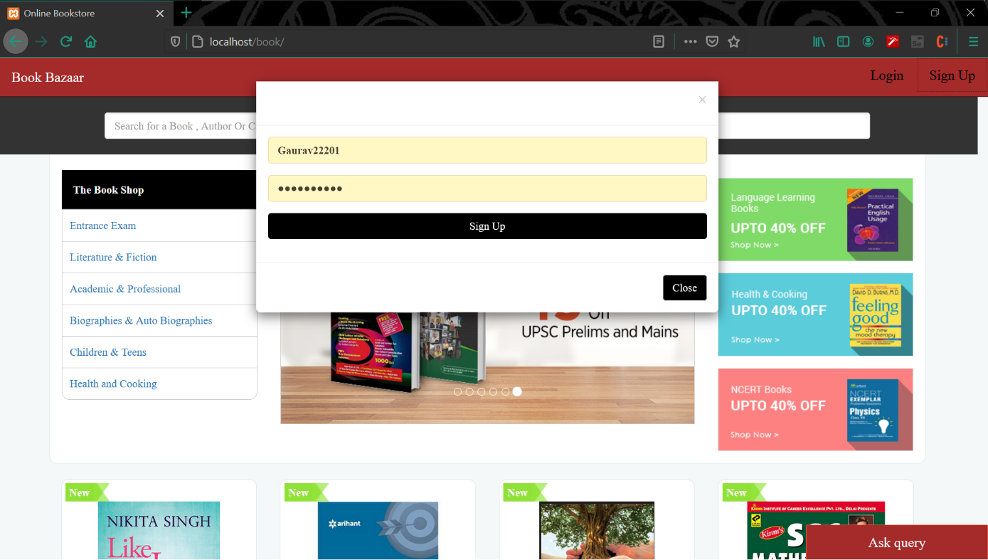

1. **Homepage**

A very comprehensive and easy to understand UI that guides the user to its needs.

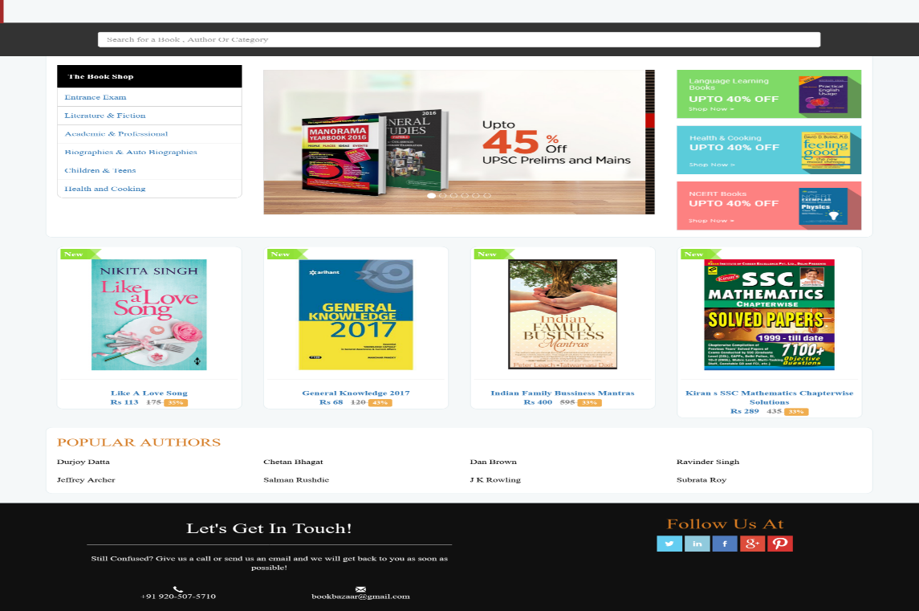

1. **Product Display: -**

Display the books as per the different categories and has a sort bar to that’s helps buyer to sort the books as per convenience.

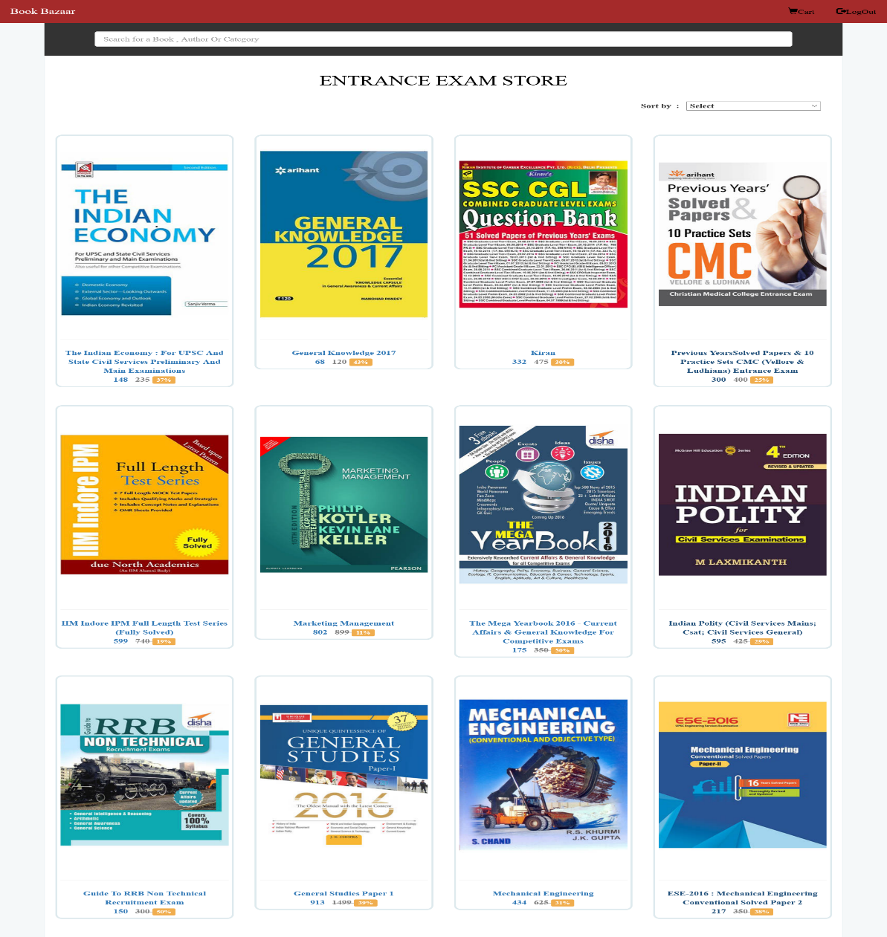

1. **Query: -**

Let the buyer ask the queries regarding anything related to books, services, pricing etc.

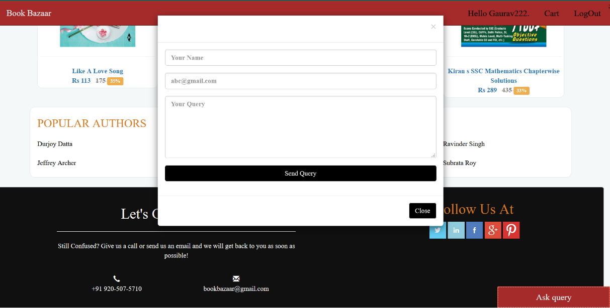

1. **Book Info: -**

Shows information about a certain book.

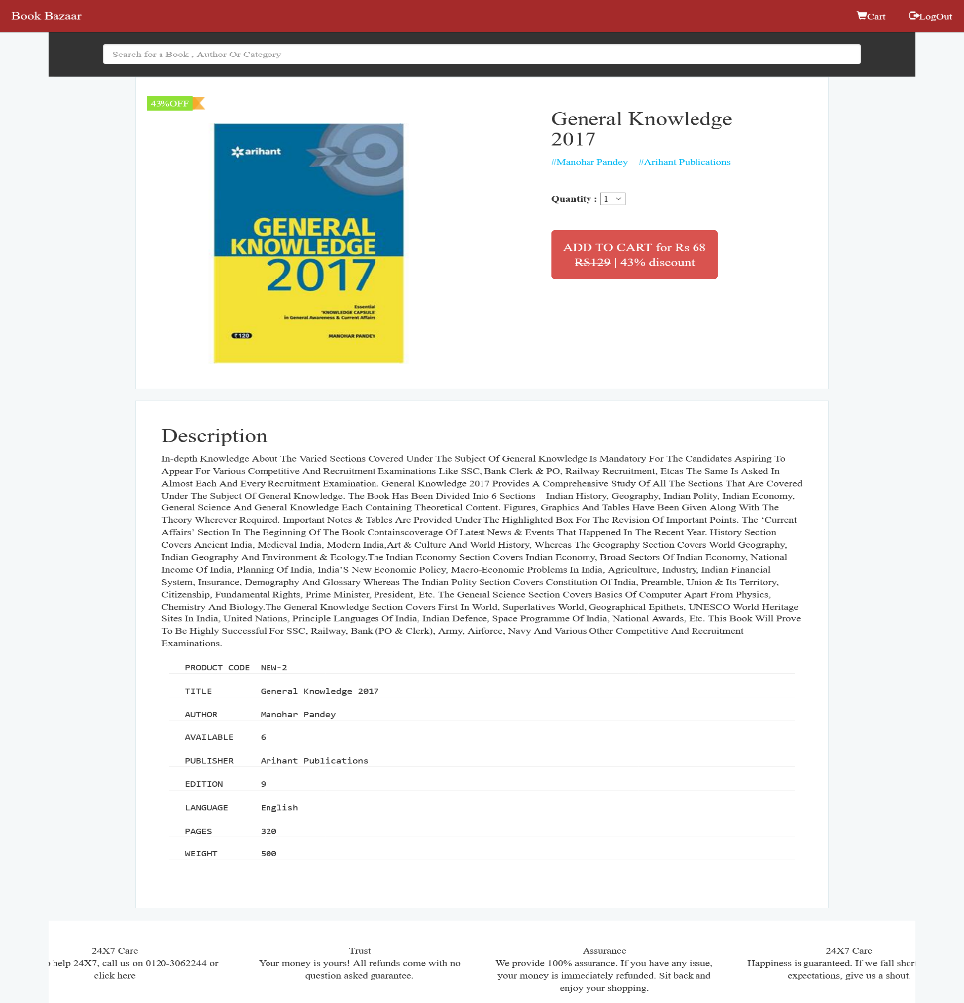

1. **Cart: -**

Let the user crosscheck his/her selected books and pay for it.

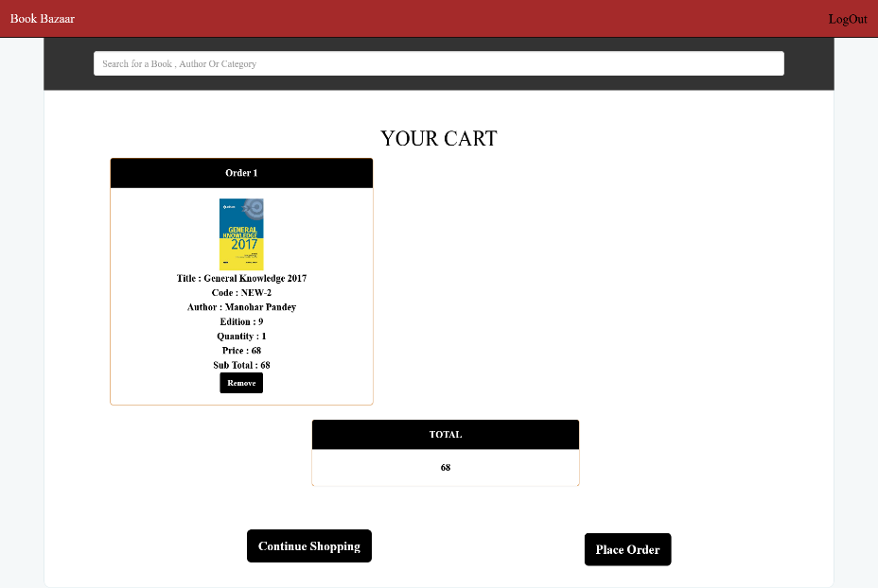

1. **Order Confirmation: -**

Let User know that the order is placed.

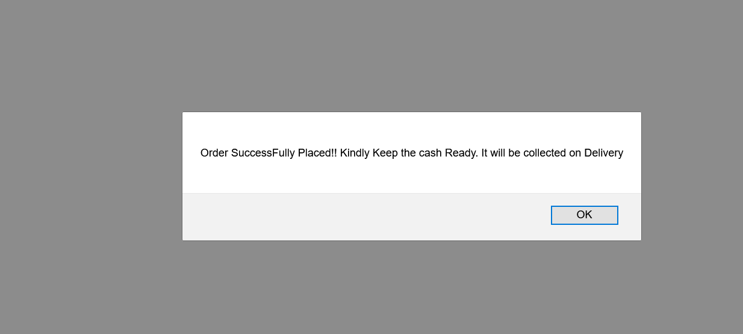

1. **Database: -**

Three databases are included:

1. User: to store user info.
2. Cart: to store orders from a user.
3. Product: to store the book details.

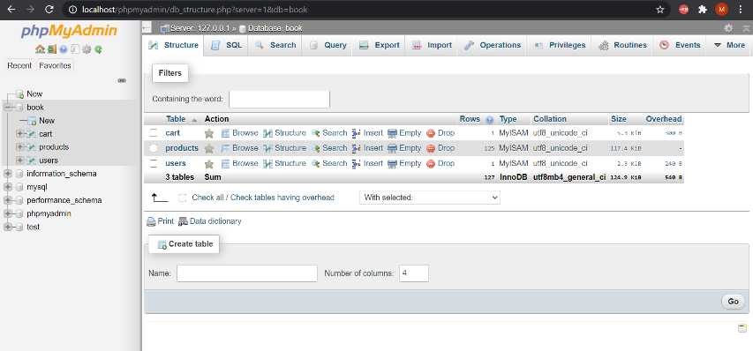

1. **Files Includes: -**

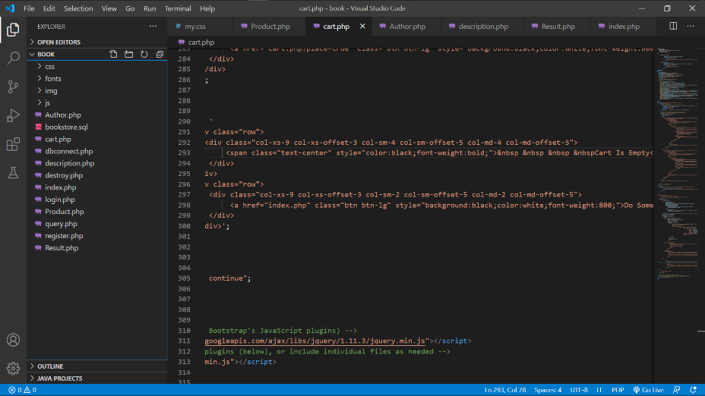

There might me some CSS errors like alignments and colors etc. Do ignore that as it can be fixed in the next build.